**In order to achieve the 70-487 Microsoft Certified Solutions Developer (MCSD) Web Applications Certification you must work your way through three prerequisite certification exams. You can choose between one of three Microsoft Technology Associate (MTA) exams the 98-361/375/380.**

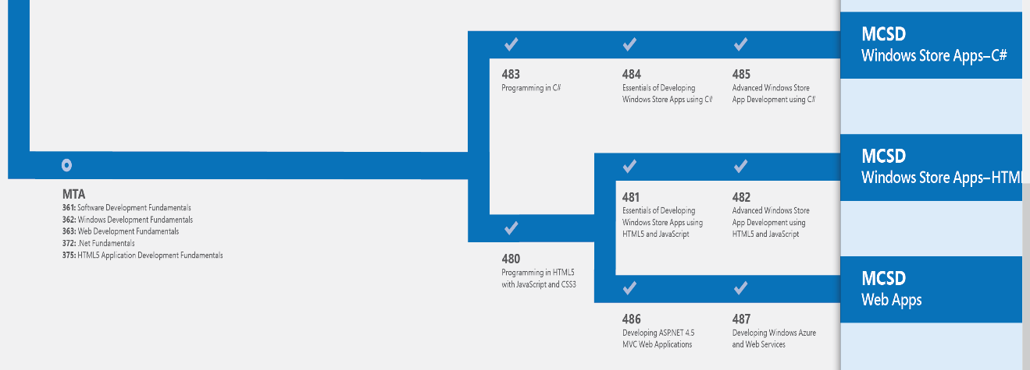

**Exam 98-361 Software Development Fundamentals**

Candidates for this exam are seeking to prove core software development skills. It is recommended that candidates be familiar with the concepts of and have hands-on experience with the technologies described here either by taking relevant training courses or by working with tutorials and samples available on MSDN and in Microsoft Visual Studio. Candidates are expected to have some experience with C# or Microsoft Visual Basic .NET.

**Exam 98-375 HTML5 App Development Fundamentals**

Candidates for this exam are seeking to prove core HTML5 client application development skills that will run on today's touch-enabled devices (PCs, tablets, and phones). Although HTML is often thought of as a web technology that is rendered in a browser to produce a UI, this exam focuses on using HTML5, CSS3, and JavaScript to develop client applications. Before taking this exam, candidates should have solid foundational knowledge of the topics outlined in the preparation guide, including CSS and JavaScript. It is recommended that candidates be familiar with the concepts of and have some hands-on experience with the related technologies, either by taking relevant training courses or by working with tutorials and samples available on MSDN and in Microsoft Visual Studio.

**Exam 98-380 Introduction to Programming with Block-Based Languages**

Candidates for this exam should understand algorithmic flow and implementing common program control structures. Candidates should have experience with block-based programming languages such as the Touch Develop environment from Microsoft, MIT Scratch, and Google Blockly.  
  
Candidates are expected to have some hands-on experience designing, creating, and publishing code within a block-based programming language.

**Then you must take and pass the 70-480 and 70-486 exams. The material you must learn in order to successfully pass these exams will help prepare you for the 70-487 but will still require you to continue your education before taking the exam.**

**Exam 70-480 Programming in HTML5 with JavaScript and CSS3**

Candidates for this exam should have one or more years of experience programming the essential business/application logic for a variety of application types and hardware/software platforms using JavaScript. Candidates should also have a minimum of one to two years of experience developing with HTML in an object-oriented, event-driven programming model.

**Exam 70-486 Developing ASP.NET MVC Web Applications**

Candidates for this exam should have one or more years of experience programming the essential business/application logic for a variety of application types and hardware/software platforms using JavaScript. Candidates should also have a minimum of one to two years of experience developing with HTML in an object-oriented, event-driven programming model.

**Exam 70-487 Developing Microsoft Azure Web Services**

Candidates for this exam should have one or more years of experience programming the essential business/application logic for a variety of application types and hardware/software platforms using JavaScript. Candidates should also have a minimum of one to two years of experience developing with HTML in an object-oriented, event-driven programming model.

**Microsoft Certified Solutions Developers use modern programming and scripting languages - including HTML5, CSS3, JavaScript, C# and .Net - to develop web and mobile applications that meet a range of business needs. Skill sets validated by MCSD certifications revolve around numerous popular Microsoft technology platforms, including Azure, Office, Windows, Visual Studio and SharePoint. MCSD certifications can help you get hired and advance your career in IT positions like** [**web developer**](http://www.itcareerfinder.com/it-careers/web-developer.html)**,** [**software engineer**](http://www.itcareerfinder.com/it-careers/software-engineer.html)**, and** [**mobile application developer**](http://www.itcareerfinder.com/it-careers/mobile-application-developer.html)**.**

### MCSD: App Builder

In March of 2017, Microsoft retired all of its other MCSD certifications to focus on the new, highly flexible MCSD: App Builder credential. Essentially, this certificate proves you have the expertise to build software systems and applications in both Microsoft and non-Microsoft environments.

#### Perquisites:

Before sitting for the [required MCSD exam(s)](http://www.itcareerfinder.com/it-certifications/microsoft-certifications/mcsd-certifications.html#mcsdexams), you must first earn these Microsoft certifications:

* MCSA: Web Applications – Exam 70-480 or 70-483(C#) and 70-486
* MCSA: Universal Windows Platform – 70-357(Mobile Apps) and 70-483

#### Required Exams:

After earning the prerequisite MCSA certifications, candidates must pass **ONE** of the following exams to become a certified MCSD: App Builder:

* Exam 70-534 | Architecting Microsoft Azure Solutions
* Exam 70-355 | Universal Windows Platform – App Data, Services, and Coding Patterns
* Exam 70-532 | Developing Microsoft Azure Solutions
* Exam 70-487 | Developing Microsoft Azure and Web Services
* Exam 70-488 | Developing Microsoft SharePoint Server 2013 Core Solutions
* Exam 70-489 | Developing Microsoft SharePoint Server 2013 Advanced Solutions
* Exam 70-354 | Universal Windows Platform – App Data, Services, and Coding Patterns
* Exam 70-496 | Administering Microsoft Visual Studio Team Foundation Server
* Exam 70-497 | Software Testing with Visual Studio
* Exam 70-498 | Delivering Continuous Value with Visual Studio Application Lifestyle Management